Exhibitor Application / Contract  Please complete and return this registration form to:  FSPCA PET EXPO  PO Box 192  Fredericton, NB  E3B 4Y9  by October 21, 2018  to be listed in the primary Show Guide. | 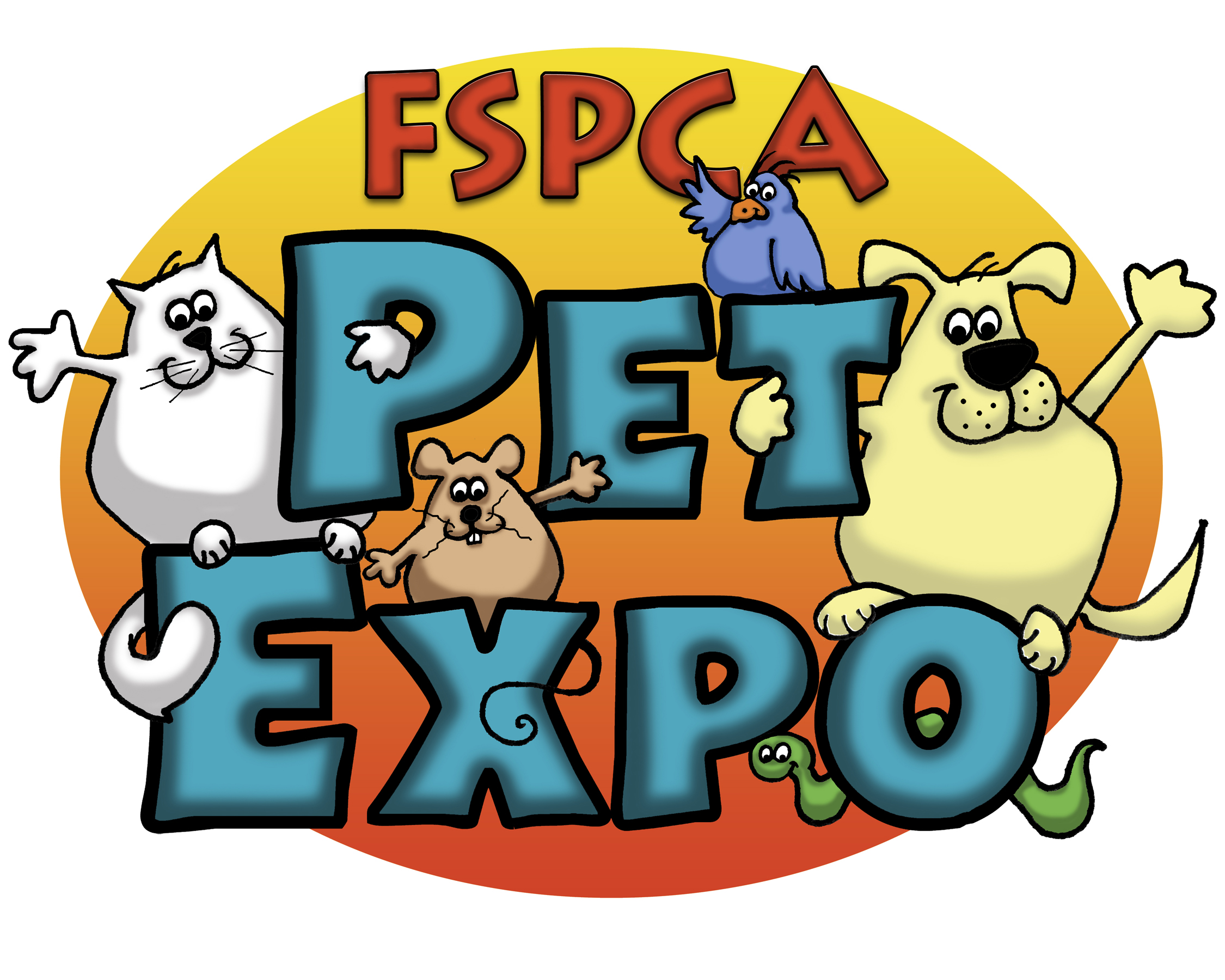
NOTE: Show Management reserves the right to accept or reject exhibition application for any reason.

BUSINESS NAME*: | *As you would like it listed in the Guide
CONTACT NAME(S):
MAILING ADDRESS:
PHONE:
EMAIL:
TYPE OF BUSINESS: | □ Home-based Business: $75 □ Small Business: $125 □ Large Business: $225 □ Not-for-Profit: $25

- YES! I am interested in EXHIBITING at the Pet Expo 2018.
□ 10’ x 10’ Booth □ 10’ x 20’ Booth (double cost of booth listed above)

All booths are provided with an 8’ back drape and 3’ side drapes and include one 6’ draped table and 2 chairs and up to 6 Exhibitor badges per booth.

- In addition to the standard exhibit items included , I would like the following:
□ Extra Draped Table(s) @ $35 □ Electricity @ $20 □ Extra Chair(s) @ No Charge

Exhibitor Application / Contract
ANIMALS:
- YES! I do plan to have live animals in my booth. The breed/species is noted below:
NOTE: You will be responsible for the cleanliness, safety and proper treatment of any animals exhibited at your booth.
PAYMENT: | - Cheque/Money Order (payable to the FSPCA Pet Expo)  enclosed in the amount of: $_____________________  - Credit Card  □ VISA or □ MasterCard payment in the amount of $_____________________  Account # ____________________________________________________  Name on Card ____________________________________________________  Expiry Date ________ / ________  I HEREBY AUTHORIZE FSPCA to process payment per the above to my Visa/MasterCard. ______(Initial here)

EXHIBITOR BADGES

Please provide the Names of any Exhibitors working your Booth. If names are not provided, generic badges will be made.


PLEASE PRINT CLEARLY

Names: #1 ________________________ #2 ________________________

I’m Exhibiting at the 2018 Fredericton SPCA Pet Expo!

______________________________ _________________________________ __________________
Authorized Exhibitor Signature Name (Please Print) Date

EVENT DISCLAIMER:
All marketing of business and merchandise will be conducted solely inside the Capital Exhibit Center. Any promotion of product or business within the Arena or the Coliseum Parking Lot is prohibited.
_______ Initial here to agree to the above disclaimer



SHOW FACILITY  Capital Exhibit Center  339 Smythe Street  Fredericton, NB  Ph. (506) 458-8819  SHOW DATES & TIMES  Move-in:  Friday, November 2: 3:00 to 6:00 pm  Show Hours:  Saturday, November 3: 10:00 to 4:00 pm  Sunday, November 4: 10:00 to 4:00 pm  Move-Out:  Sunday, November 4: 4:00 to 6:00 pm  Exhibitors may enter the exhibit hall every morning at 9:00 am; however, all exhibits are to be setup by 7:00 pm on November 2nd, 2018.  PAYMENT OF EXHIBIT SPACE MUST BE PAID IN FULL BY: NOVEMBER 2ND, 2018.  SPACE APPLICATIONS:  Show Management reserves the right to accept or reject applications at any time.  ALTERATIONS TO BUILDING:  Painting, nailing, drilling, or screwing to the floor, walls or any part of the building is not permitted.  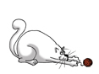 | SHOW CONTRACTOR  The official Show Contractor is FSPCA. We are responsible for the following: furniture rentals (tables, chairs, etc.) on site labor and cleaning.  For further information, please contact:  FSPCA PET EXPO  PO Box 192  Fredericton, NB E3B 4Y9  Phone: (506) 476-4188  Email: Karen@frederictonspca.ca  www.frederictonspca.ca  All booths are provided with back drape and low side rails and include a 6’ table and 2 chairs.  Additional tables are $35.00 and electricity is $20.00 extra. Additional chairs are free of charge.  BOOTH CONSTRUCTION  A. SIGNAGE  Must be incorporated into your exhibit design and height of 8’. Signage must not appear in adjacent exhibits.  B. DRAPE  All booths will be supplied with 8’ high draping at the back and 3’ high on the sides. NO draping is allowed on the aisle side of the booths. Any variation or changes in the standard draping are at the exhibitor’s expense. Nothing is to be pinned or stapled to drape(s). Hooks are available at the Show Office.  

EXHIBITOR BADGES  Please indicate how many exhibitor badges your company requires – to a maximum of 2 per booth – on your Exhibitor Form. These badges are for working booth staff ONLY.  ELECTRICAL ORDERS  If power is required – please order through the Exhibitor Contract.  SAMPLES, SOUVENIRS & SOLICITING  Soliciting of business and/or distribution of samples and souvenirs will not be permitted in the aisles, the parking lots, arena or in another exhibitor’s booth, but must be confined to the exhibitor’s own booth space.  HANDLING OF EXHIBITS, MATERIALS AND EQUIPMENT  Should your display require the use of heavy duty unloading equipment, you are requested to notify management in advance of Show time so that arrangements can be made to have it available.  Costs of renting and operating such equipment are the responsibility of the exhibitor.  Exhibitors who can supply their own trucks and dollies are urged to do so.  DOG ‘RELIEF’ AREAS  Dog Relief Areas will be designated on special grass/mulch areas for dogs to be walked and for ‘relieving’ themselves. Please be considerate of our venues and clean up after your animals.   | INSURANCE  Show Management, the FSPCA PET EXPO, Capital Exhibit Centre, and the City of Fredericton will not be responsible for injury to persons, loss or damage of products, exhibits, equipment or decorations by fire, accident, theft or any other cause while in the Show building or it’s environs.  NOTE: Exhibitors must consult with their own insurance broker to ensure that they are insured against all risks to either personnel or equipment and public liability (animal bites, scratches, escapes, etc.)  Exhibitors are responsible for security in their booth for the full duration of the show. During move-in and move-out, please have a staff member in your booth at all times.  Show Management cannot assume any responsibility for losses incurred from pilfering or any other causes.  PRIZES & DRAWS  Exhibitors offering draws in-booth are required to provide their own entry forms, draw boxes and signage for their prize draws.  Exhibitors are responsible to obtain any pertinent license or permit for raffles.  Please Note: winning announcements will not be made over the facility sound system.  FIRE SAFETY  No Exhibitor shall use any flammable decorations or covering for display fixtures and all fabrics or other material used for decoration or covering of tables and/or risers shall be flameproof.

ANIMAL HOUSING REGULATIONS  (a) Cleanliness  Show Management requests that all stalls, kennels, litter and shavings receive immediate attention for removal of waste matter on an ongoing basis.  (b) Condition of Animals  Animals should be in excellent health and well groomed. Animals with open wounds, sores or broken appendages will not be allowed at the Show.  (c) Bathing Animals  The Show will not be providing any areas for wash-downs, so please prepare your animal prior to the Show.  (d) Density  Animals should not be overcrowded in their cages. Access to food, water, a perch, basking rock or displaying area is essential for each animal.  (e) Adequate Enclosures  All animals must be confined in suitable containers or fencing that provides a clear and unobstructed view of the contents and live exhibits therein. Exhibitors assume all liabilities and/or obligations caused by faulty or improper displays. A good enclosure will provide good ventilation and be secure. Many animals can escape through extremely small openings.  Consideration must also be given to the possible escape of smaller offspring. It is preferable that the public does not have access to the animals in order to prevent possible feeding, harassment, injury or poisoning. Animals that the public has access to must have an escape area to where they cannot be handled, or sufficiently scheduled breaks, so that human contact does not become ‘too much’ for them. Every enclosure should be appropriate for the size, adaptations and behavior of the species. It should be large enough for the animal to comfortably extend to its fullest dimension (wingspan, nose to tail, height, etc.) with the possible exception of snakes. Appropriate cage furniture and substrate will allow the expression of the species’ behaviour, i.e.: burrowing, swimming, etc. | RESTRICTED ANIMALS  All animals exhibited must meet the restrictions and regulations set forth in the NB Wildlife Act. Any exhibitors failing to comply with this Act (by the display of regulated or restricted animals without proper permits) will be asked to leave the Show and/or remove the animals and may face further legal consequences as applied by NB Wildlife officers.  ANIMAL SECURITY  Every effort will be made to ensure that only approved handlers may remove animals from the Show (people attempting to leave the Show must be wearing a visible Exhibitor or Presenter pass, or have a receipt of purchase for feeder animals). However, the PET EXPO does not resume any responsibility for lost or stolen animals at the Show. Exhibitors agree to hold harmless the PET EXPO and all suppliers to the PET EXPO for the loss, theft or damage to any animals caused by the PET EXPO staff and/or attendees of the Show, Handlers and Exhibitors assume all responsibility for the care, control, security and moving of animals.  ANIMAL CONTROL  Animals must be leashed, caged or fully contained at all times (except during presentations) with the possible exception of Exhibitor’s ‘pocket pets’ (i.e. flying squirrels, spiny mice) and manageable hook-bills (with clipped wings). Every attempt must be made to restrict the possible escape of any animals during the Show or after hours.  ANIMAL ESCAPING  Should your animal escape during public hours or during the night, you will be contacted immediately. All Exhibitors are responsible for their animals left overnight. You will be asked to help retrieve the escaped animal. But the best approach is prevention – make sure your animals are secure for the night in their cage.  In the event that an escaped animal harms another Exhibitor’s animal, the PET EXPO assumes no responsibility for the damage and/or death of that animal. Exhibitors are fully responsible for the protection and containment of the animals in their care.

